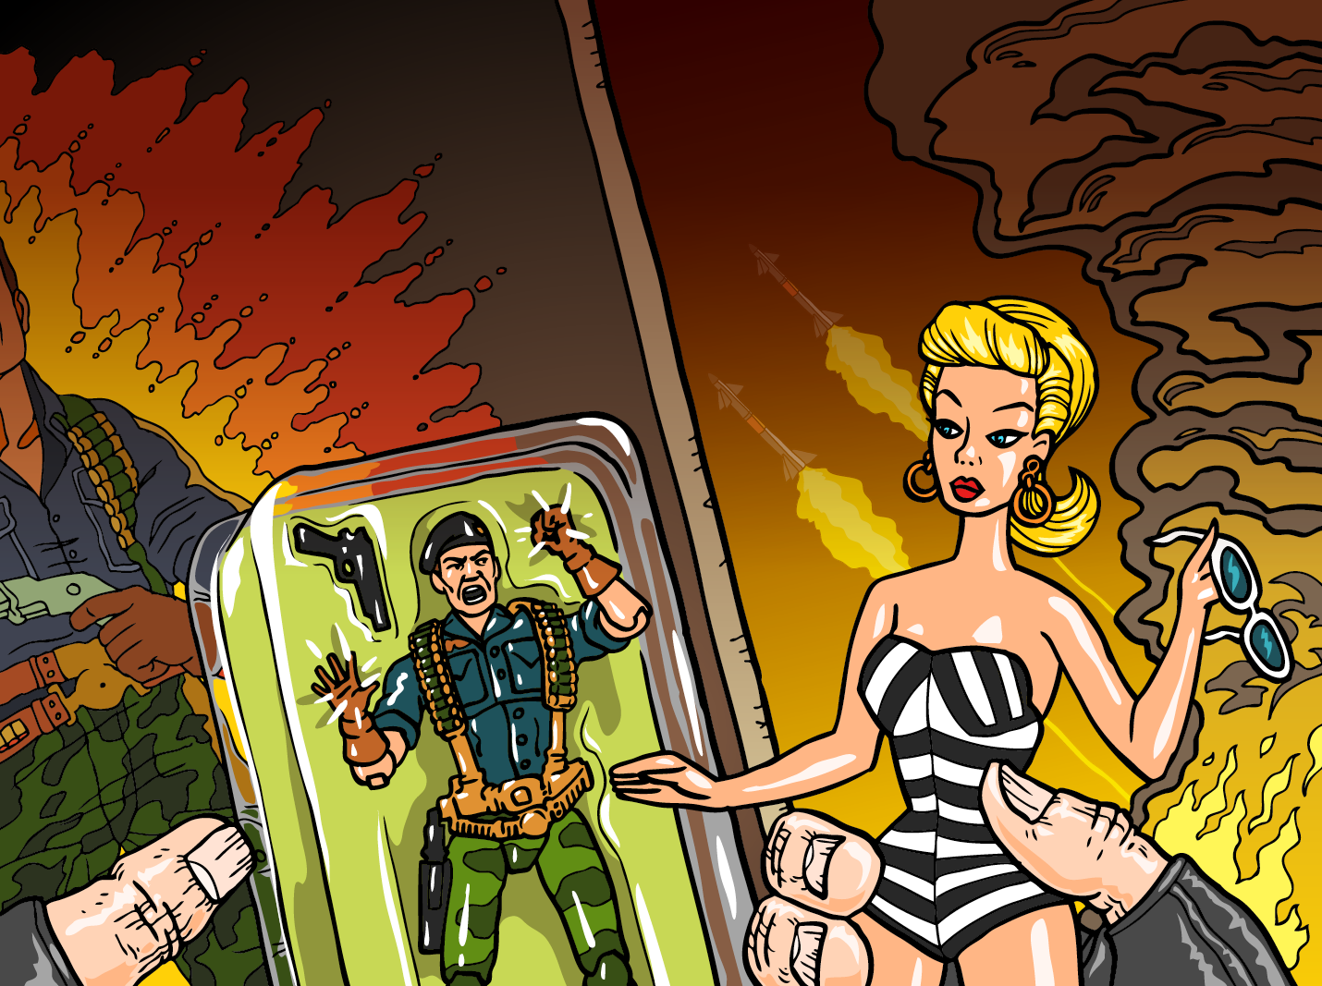

Los Angeles, CA (June 4, 2014) Hollywood Fringe Festival Favorite, Master Storyteller, and Voiceover Artist, Bill Ratner--the cartoon voice of G.I. Joe’s “Flint,” and noted film and TV actor Clay Wilcox come to the 2014 Fringe with The True Life Adventures of Barbie and G.I. Joe, directed by Fringe, TV, & film veteran, Sydney Walsh. Performances are Wednesday through Friday at 7:30 p.m. and Saturday at 9:15 p.m., June 18th through 28th at The Complex Theaters, Ruby Room (6476 Santa Monica Blvd. Hollywood, 90038). Press Comps & tickets are available at: http://www.hollywoodfringe.org/projects/1688

The True Life Adventures of Barbie and G.I. Joe features the world's toughest super-soldiers and America’s iconic blond bimbo in a steamy true story of media terrorism, life as a mega-toy, and the fleecing of families worldwide. Hang out in the recording booth with the TV Cartoon voice of G.I. Joe’s “Flint,” and follow media terrorists into the toy store for the wildly funny, true story of the most effective mega-merchandising campaigns (and the sneakiest voice transformations) in the history of toydom. Learn why Mattel’s mom felt the world needed Barbie. Across town Mr. Potato Head’s profits were sagging. No longer just a 12-inch male Barbie-doll, G.I. Joe morphed into a team of 3 3/4-inch master-fighters who would battle world terrorism, and together with Barbie, overpower the wallets of children everywhere. From the darkest Christmas night, to the G.I. Joe voiceover auditions, to the gathering of real live troops at G.I. Joe/Con, featuring two toy swapping bro’s desperate to keep running the show, hear the story of Barbie and G.I. Joe as it’s never been told before.

Bill Ratner (Writer/Performer) is a Two-Time Winner of Best of Hollywood Fringe Extension, one of Hollywood’s most successful voiceover performers, a 9-time winner of The Moth StorySLAMs, and his stories are featured on KCRW’s “Strangers,” and NPR’s “The Business” and “Good Food.” He is heard on movie trailers: Peabody & Sherman, Rio 2, The Incredible Burt Wonderstone, On The Road, Will Ferrell's The Campaign, Casa de mi Padre, Talladega Nights, promos for CBS-TV's hit show Under the Dome, commercials for V-8, Sprint, Pizza Hut, Hyundai, and he is the voice of "Flint" on the original G.I. Joe animated series - a role he reprised for Robot Chicken, and Family Guy. He is "Donnel Udina" in Mass Effect 1, 2 & 3; the radio voice on Grand Theft Auto, the voice of documentary programs Air Disasters, I Almost Got Away With It, and Behind Mansion Walls on Discovery and Smithsonian, and he performs in nightclubs, theaters, and storytelling festivals around the country. Bill was honored with BEST OF HOLLYWOOD FRINGE EXTENSION in 2012 and 2013 for his two previous solo shows, Bobbywood and Voices in my Head. Bill teaches voiceovers for SAG-AFTRA and the Screen Actors Guild Foundation Don La Fontaine Memorial Voiceover Laboratory where he serves on the advisory board. More information at http://www.billratner.com.

Clay Wilcox is a TV and film veteran actor, having appeared in the acclaimed
Deadwood, CSI, and True Blood.
Clay Wilcox IMDB: http://www.imdb.com/name/nm0928186/?ref_=fn_al_nm_1

For more information about the show please go to http://www.hff14.org/1688.
The True Life Adventures of Barbie and G.I. Joe performances are Wednesday
through Friday at 7:30 p.m. and Saturday at 9:15 p.m. The show runs June
18th through June 28th at The Complex Theaters, Ruby Room (6476 Santa
Monica Blvd. Hollywood, 90038). Tickets & Press passes are $10 and
available at http://www.hollywoodfringe.org/projects/1688

